CYBERBULLYING RISK PREDICTION USING MACHINE LEARNING

A PROJECT REPORT

Submitted by

ARCHANA RS (8115U24AM008)

in partial fulfilment for the award of the course

AMB 1221-MACHINE LEARNING FUNDAMENTALS IN

DEPARTMENT OF COMPUTER SCIENCE AND ENGINEERING

(ARTIFICIAL INTELLIGENCE AND MACHINE LEARNING)


K. RAMAKRISHNAN COLLEGE OF ENGINEERING

(AUTONOMOUS) SAMAYAPURAM, TRICHY


ANNA UNIVERSITY CHENNAI 600 025

MAY 2026

CYBERBULLYING RISK PREDICTION USING MACHINE LEARNING

A PROJECT REPORT

Submitted by

ARCHANA RS (8115U24AM008)

in partial fulfilment for the award of the course

ADI1221-MACHINE LEARNING FUNDAMENTALS IN

DEPARTMENT OF COMPUTER SCIENCE AND ENGINEERING
(ARTIFICIAL INTELLIGENCE AND MACHINE LEARNING)

Under the Guidance of Mrs. C.MUTHUSELVI

Department of Artificial Intelligence and Data Science
K. RAMAKRISHNAN COLLEGE OF ENGINEERING



K. RAMAKRISHNAN COLLEGE OF ENGINEERING

(AUTONOMOUS)

ANNA UNIVERSITY, CHENNAI



K. RAMAKRISHNAN COLLEGE OF ENGINEERING (AUTONOMOUS)

ANNA UNIVERSITY, CHENNAI

BONAFIDE CERTIFICATE

Certified that this project report titled “CYBERBULLYING RISK PREDICTION USING MACHINE LEARNING” is the Bonafide work of ARCHANA RS (8115U24AM008) who carried out the work under my supervision.

SIGNATURE SIGNATURE

Dr. B.KIRAN BALA, M.E.,M.B.A.,Ph.D., Mrs. C. MUTHUSELVI M.E., HEAD OF THE DEPARTMENT, SUPERVISOR,

ASSOCIATE PROFESSOR, ASSISTANT PROFESSOR,
Department of Artificial Intelligence Department of Artificial Intelligence and Machine Learning, and Data Science,
K. Ramakrishnan College of K. Ramakrishnan College of
Engineering, (Autonomous) Engineering, (Autonomous)
Samayapuram, Trichy. Samayapuram, Trichy.

SIGNATURE OF INTERNAL EXAMINER SIGNATURE OF EXTERNAL EXAMINER

NAME: NAME:
DATE: DATE:

iii



K. RAMAKRISHNAN COLLEGE OF ENGINEERING (AUTONOMOUS)

ANNA UNIVERSITY, CHENNAI

DECLARATION BY THE CANDIDATE

I declare that to the best of my knowledge the work reported here in has been composed solely by myself and that it has not been in whole or in part in any previous application for a degree.

Submitted for the project Viva-Voice held at K. Ramakrishnan College of Engineering on

SIGNATURE OF THE CANDIDATE

ACKNOWLEDGEMENT

I thank the almighty GOD, without whom it would not have been possible for me to complete my project.
I wish to address my profound gratitude to Dr.K.RAMAKRISHNAN, Chairman,
K. Ramakrishnan College of Engineering(Autonomous), who encouraged and gave me all help throughout the course.
I extend my hearty gratitude and thanks to my honorable and grateful Executive Director Dr.S.KUPPUSAMY, B.Sc., MBA., Ph.D., K. Ramakrishnan College of Engineering(Autonomous).
I am glad to thank my Principal Dr.D.SRINIVASAN, M.E., Ph.D.,FIE., MIIW., MISTE., MISAE., C.Engg, for giving me permission to carry out this project.
I wish to convey my sincere thanks to Dr.B.KIRAN BALA, M.E., M.B.A., Ph.D., Head of the Department, Artificial Intelligence and Data Science for giving me constant encouragement and advice throughout the course.
I am grateful to Mrs. C.MUTHUSELVI, M.E., Assistant Professor, Artificial Intelligence and Data Science, K. Ramakrishnan College of Engineering (Autonomous), for her guidance and valuable suggestions during the course of study.
Finally, I sincerely acknowledged in no less terms all my staff members, my parents and, friends for their co-operation and help at various stages of this project work.

ARCHANA RS (8115U24AM008)

K. RAMAKRISHNAN COLLEGE OF ENGINEERING



(AUTONOMOUS) ANNA UNIVERSITY, CHENNAI

DEPARTMENT OF CSE (ARTIFICIAL INTELLIGENCE AND MACHINE LEARNING)

VISION
To become a renowned hub for AIML technologies to producing highly talented globally recognizable technocrats to meet industrial needs and societal expectation.

MISSION

Mission of the Department
M1 To impart advanced education in AI and Machine Learning, built upon a foundation in
Computer Science and Engineering.
M2 To foster Experiential learning equips students with engineering skills to tackle real-world problems.
M3 To promote collaborative innovation in AI, machine learning, and related research and development with industries.
M4 To provide an enjoyable environment for pursuing excellence while upholding strong personal and professional values and ethics.

PROGRAM EDUCATIONAL OBJECTIVES (PEO’s)
PEO1 Excel in technical abilities to build intelligent systems in the fields of AI & ML in order to find new opportunities.
PEO2 Embrace new technology to solve real-world problems, whether alone or as a team, while prioritizing ethics and societal benefits.
PEO3 Accept lifelong learning to expand future opportunities in research and product development.

PROGRAM SPECIFIC OUTCOMES (PSO’s)
PSO1 Expertise in tailoring ML algorithms and models to excel in designated applications and fields.

PSO2 Ability to conduct research, contributing to machine learning advancements and innovations that tackle emerging societal challenges.

PROGRAM OUTCOMES (POs)
Engineering students will be able to:

PO1 Engineering knowledge: Apply the knowledge of mathematics, science, engineering fundamentals, and an engineering specialization to the solution of complex engineering problems. PO2 Problem analysis: Identify, formulate, review research literature, and analyze complex engineering problems reaching substantiated conclusions using first principles of mathematics, natural sciences, and engineering sciences.
PO3 Design/development of solutions: Design solutions for complex engineering problems and design system components or processes that meet the specified needs with appropriate consideration for the public health and safety, and the cultural, societal, and environmental considerations.
PO4 Conduct investigations of complex problems: Use research-based knowledge and research methods including design of experiments, analysis and interpretation of data, and synthesis of the information to provide valid conclusions.
PO5 Modern tool usage: Create, select, and apply appropriate techniques, resources, and modern engineering and IT tools including prediction and modelling to complex engineering activities with an understanding of the limitations.
PO6 The Engineer and Society: Apply reasoning informed by the contextual knowledge to assess societal, health, safety, legal and cultural issues and the consequent responsibilities relevant to the professional engineering practice.
PO7 Ethics: Apply ethical principles and commit to professional ethics and responsibilities and norms of the engineering practice.
PO8 Individual and team work: Function effectively as an individual, and as a member or leader in diverse teams, and in multidisciplinary settings
PO9 Communication: Communicate effectively on complex engineering activities with the engineering community and with society at large, such as, being able to comprehend and write effective reports and design documentation, make effective presentations, and give and receive clear instructions.
PO10 Project management and finance: Demonstrate knowledge and understanding of the engineering and management principles and apply these to one’s own work, as a member and leader in a team, to manage projects and in multidisciplinary environments.
PO11 Life-long learning: Recognize the need for and have the preparation and ability to engage in independent and life-long learning in the broadest context of technological change.

ABSTRACT

Cyberbullying has become a serious issue with the rapid growth of social media and online communication platforms. It involves the use of digital technologies to harass, threaten, or harm individuals, leading to emotional distress and psychological problems. This project focuses on developing a system to predict and detect cyberbullying using machine learning techniques.
The proposed system collects textual data from online sources such as social media comments, messages, and forums. The data is preprocessed to remove noise and convert it into a suitable format for analysis. Various feature extraction techniques such as TF-IDF and word embeddings are used to transform text into numerical representations. Machine learning algorithms like Logistic Regression, Naive Bayes, and Support Vector Machine are applied to classify the data into bullying and non-bullying categories.This project demonstrates the effectiveness of machine learning in addressing real-world social issues like cyberbullying.

ABSTRACT WITH POs AND PSOs MAPPING

ABSTRACT | POs MAPPED | PSOs MAPPED
The CYBERBULLYING RISK PREDICTION USING MACHINE LEARNING system is
developed to predict property prices using | PO1-3
machine learning techniques. It analyzes  factors such as location, plot size, road | PO2-3
width, number of bedrooms, and | PO3-3 | PSO1 – 3
bathrooms to generate accurate price |  | PSO2 – 3
estimates. The system uses a Linear | PO4-3
Regression model and is implemented as a | PO5-3
web-based application using Python and
Flask. It includes modules like user | PO6-3
authentication, sector selection, property | PO7-3
search, prediction, and map visualization.
Users can input their requirements and | PO8-3
receive instant results with suitable  property suggestions. The system is fast, | PO9-3
efficient, and easy to use, requiring | PO10-3
minimal computational resources. It helps
reduce manual effort and supports better | PO11-3
decision-making in real estate analysis.
Overall, the project demonstrates the
effective use of artificial intelligence in
solving real-world problems.
Note: 1- Low, 2-Medium, 3- High

TABLE OF CONTENTS

C | HAPTER  TITLE PAGE No.  No.
 |  | ABSTRACT | v
 |  | LIST OF ABBREVIATIONS | x
 |  | LIST OF FIGURES | xi
1 |  | INTRODUCTION | 1
 |  | 1.1 Objective | 1
 |  | 1.2 Overview | 1
 |  | 1.3 Purpose and Importance | 2
 |  | 1.4 Data Source Description | 2
 |  | 1.5 Project Summarization | 3
2 |  | LITERATURE SURVEY | 4
 |  | 2.1 Introduction and Traditional Methods | 4
  - Machine Learning Techniques for Price
4
Prediction
  - Web-Based Systems and Visualization
5
Techniques
  - Limitations of Existing Systems and
5
Summary

- PROJECT METHODOLOGY 6
  - Proposed Workflow 6
  - Architectural Overview 7
  - Hardware and Software Requirements 8
  - System Integration and Working 8
- RELEVANCE OF THE PROJECT 9
  - Why the Model Was Chosen 9
  - Comparison with Other Models 9
  - Advantages and Disadvantages 10
  - Summary of Relevance 11
- MODULE DESCRIPTION 12
  - User Authentication Module 12
  - Sector Selection Module 12
  - Property Search Module 13
  - Machine Learning Prediction Module 13
  - Map Module 14
  - Map Visualization Module 15
  - Flask Server (Central Controller) 15
- RESULT AND DISCUSSION 16
  - Performance Analysis 16
  - User Feedback 16
- CONCLUSION AND FUTURE WORK 18
  - Summary of Outcomes 18
  - Future Scope and Enhancements 18
- APPENDIX 20
APPENDIX A – Source Code 20
APPENDIX B – Screenshots 25
REFERENCES 27

LIST OF FIGURES

FIGURE NO. |  | TITLE |  | PAGE NO.
 | 3.2.1 |  | System Architecture |  | 8
 | 5.4.1 |  | Linear Regression Model |  | 14
 | B.1 |  | Login Interface |  | 25
 | B.2 |  | Sector Selection Screen |  | 25
 | B.3 |  | Prediction Result Output |  | 26
 | B.4 |  | Property Search Form |  | 26

LIST OF ABBREVIATIONS

S. NO. | ACRONYM | ABBREVIATION
1 | C | Artificial Intelligence
2 | API | Application Programming Interface
3 | DBMS | Database Management System
4 | GUI | Graphical User Interface
5 | ML | Machine Learning
6 | SQL | Structured Query Language
7 | UI | User Interface

CHAPTER 1 INTRODUCTION
  - Objective

The main objective of this project is to develop an intelligent system that can detect and classify cyberbullying content from online text data. The system aims to collect and preprocess data from various digital platforms such as social media comments, chats, and posts to ensure accurate analysis. It focuses on applying machine learning algorithms like Logistic Regression, Naive Bayes, and Support Vector Machine to effectively identify harmful content.
Additionally, the project seeks to transform textual data into numerical form using feature extraction techniques such as TF-IDF for better model performance. Another important objective is to predict the level of cyberbullying risk as low, medium, or high, which helps in understanding the severity of the content. The system is designed to improve accuracy and reliability while enabling early detection and prevention of cyberbullying.
Overall, the objective is to create a practical and efficient solution that can be implemented in real-time applications to promote safer and more secure online communication environments.

  - Overview

Cyberbullying has emerged as a major concern in today’s digital world, where people активно communicate through social media platforms, messaging applications, and online forums. It involves the use of electronic communication to harm, threaten, or embarrass individuals, often leading to serious emotional and psychological effects. Due to the increasing volume of online interactions, manual monitoring of such harmful content has become difficult, creating a need for automated solutions.This project presents a machine learning-based approach to predict and detect cyberbullying in textual data and non-bullying content.

  - Purpose and Importance

The purpose of this project is to develop an efficient and intelligent system that can automatically detect and predict cyberbullying in online communication using machine learning techniques. With the rapid growth of social media platforms and digital interactions, cyberbullying has become a serious issue affecting individuals emotionally and psychologically. This project aims to analyze textual data such as messages, comments, and posts to identify harmful or abusive content at an early stage. By applying machine learning algorithms, the system can classify content as bullying or non-bullying and further determine the level of risk involved. The importance of this project lies in its ability to provide a proactive solution to a growing social problem. Manual monitoring of online content is time-consuming and inefficient due to the vast amount of data generated every day. An automated system helps in faster detection, reducing human effort, and improving accuracy.

  - Data Source Description

The data used in this project is primarily collected from publicly available online platforms such as social media websites, discussion forums, and chat-based applications, where user-generated textual content is abundant. These sources include comments, posts, messages, and reviews that may contain both normal and abusive language. In addition to real-time data, standard datasets from platforms like Kaggle and research repositories are also utilized to ensure the availability of labeled data for training and testing purposes. These datasets typically consist of text samples categorized as cyberbullying or non-cyberbullying, which helps in building accurate machine learning models.Before using the data, it undergoes a preprocessing phase where unnecessary elements such as special characters, URLs, and stop words are removed to improve data quality. The cleaned data is then structured and formatted for analysis

The use of diverse and well-labeled datasets ensures that the model can learn different patterns of cyberbullying language, making it more effective and reliable in real-world scenarios. Overall, the data sources play a crucial role in enhancing the performance and accuracy of the cyberbullying detection system. To improve the quality and usability of the data, a preprocessing step is carried out. This includes removing noise such as special characters, emojis, hyperlinks, and irrelevant symbols. The text is then converted into lowercase, and stop words (commonly used words with little meaning) are eliminated. Tokenization and stemming or lemmatization techniques are applied to normalize the text and reduce redundancy.

  - Project Summarization

This project focuses on developing an intelligent system to detect and predict cyberbullying in online communication using machine learning techniques. With the increasing use of social media and digital platforms, cyberbullying has become a serious issue that affects individuals emotionally and psychologically. The main aim of this project is to automatically identify harmful or abusive content in textual data such as comments, messages, and posts.

The system begins by collecting data from various sources, including social media platforms and publicly available datasets. The collected data is then preprocessed to remove noise and improve quality. Feature extraction techniques such as TF-IDF are used to convert text into numerical form suitable for machine learning models. Various algorithms like Logistic Regression, Naive Bayes, and Support Vector Machine are applied to classify the data into bullying and non-bullying categories.

CHAPTER 2 LITERATURE SURVEY

  - Introduction and Traditional Methods

Cyberbullying has become a significant problem in the modern digital era due to the widespread use of social media platforms, messaging applications, and online communication tools. It refers to the act of using electronic communication to harass, threaten, or humiliate individuals. Victims of cyberbullying often experience emotional distress, anxiety, and psychological issues. With the massive growth of online content, it has become increasingly difficult to manually monitor and control such harmful activities. Therefore, there is a strong need for automated systems that can efficiently detect and prevent cyberbullying, leading to the use of machine learning techniques for accurate and fast prediction. This led to the development of machine learning-based approaches, which provide more accurate, scalable, and efficient solutions for cyberbullying detection.

  - Machine Learning Techniques for Price Prediction

Machine learning techniques play a crucial role in price prediction by analyzing historical data and identifying patterns to forecast future values. Price prediction is widely used in various fields such as stock markets, real estate, and e-commerce, where accurate estimation of future prices is essential for decision-making. These techniques use mathematical models and algorithms to learn from past data and make predictions without explicit programming.
One of the most commonly used techniques is linear regression, which establishes a relationship between input variables and the target price. For more complex scenarios, multiple linear regression is used,

  - Web-Based Systems and Visualization Techniques

A web-based system plays an important role in implementing machine learning models for applications such as price prediction or cyberbullying detection. It provides a user-friendly interface where users can interact with the system through a web browser without needing any specialized software. The system typically consists of a front-end and a back-end. The front-end is designed using technologies like HTML, CSS, and JavaScript to create an interactive user interface, while the back-end is developed using programming languages such as Python, along with frameworks like Flask or Django to handle data processing and model execution. The machine learning model is integrated into the back-end, allowing users to input data and receive predictions in real time. This makes the system accessible, scalable, and easy to use across different devices and platforms.

  - Limitations of Existing Systems and Summary

The existing systems for detecting cyberbullying or performing price prediction mainly rely on traditional methods such as manual monitoring, rule-based filtering, and basic statistical approaches. These systems have several limitations that affect their efficiency and accuracy. Manual monitoring requires significant human effort and is not feasible for handling large volumes of data generated on digital platforms. Rule-based systems depend on predefined keywords or patterns, which makes them inflexible and unable to adapt to new or evolving language styles. They often fail to detect context, sarcasm, or indirect forms of harmful content, leading to inaccurate results. Additionally, traditional models lack scalability and struggle to process real-time data efficiently. In the case of price prediction, conventional methods may not capture complex relationships between variables, resulting in poor prediction performance.

CHAPTER 3 PROJECT METHODOLOGY
The methodology of this project follows a systematic approach to develop an efficient cyberbullying detection and risk prediction system using machine learning techniques. The first step involves data collection, where textual data is gathered from various sources such as social media platforms, online forums, and publicly available datasets. This data includes both bullying and non-bullying content, which is essential for training the model. Once the data is collected, it undergoes a preprocessing phase to improve its quality. This step includes removing unwanted elements such as special characters, URLs, and stop words, as well as converting the text into lowercase.

Proposed Workflow

The proposed workflow of the cyberbullying risk prediction system follows a structured sequence of steps to ensure accurate detection and classification of harmful content. The process begins with data collection, where textual data such as comments, messages, and posts are gathered from social media platforms and publicly available datasets. This data forms the foundation for training the machine learning model.

Once the data is collected, it undergoes preprocessing to remove noise and improve quality. This includes eliminating special characters, URLs, and stop words, as well as converting all text into lowercase. Techniques such as tokenization and lemmatization are applied to standardize the text and make it suitable for analysis.
The next step involves feature extraction, where the cleaned text is converted into numerical format using methods like Bag of Words (BoW) or TF-IDF. These features help the model understand the importance and frequency of words in the dataset.

Architectural Overview

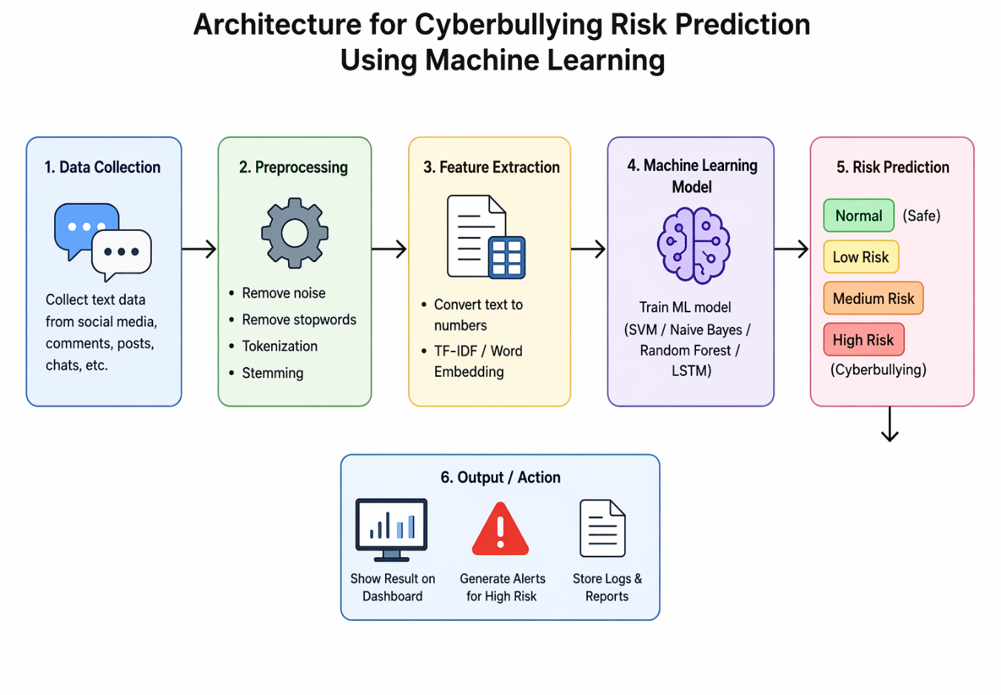

Fig 3.2.1 Architecture Diagram

The system architecture of the cyberbullying risk prediction model is designed to efficiently process textual data and provide accurate predictions through a series of interconnected components. The architecture consists of multiple layers, including data input, preprocessing, feature extraction, model training, and prediction output, all working together to ensure smooth functionality of the system.
Initially, the data input layer collects textual data such as user comments, messages, and posts from various sources like social media platforms and datasets. This data is then passed to the preprocessing layer, where noise such as special characters, URLs, and stop words are removed. The text is also normalized using techniques like tokenization and lemmatization to make it suitable for further processing.

Hardware and Software Requirements

The successful implementation of the cyberbullying risk prediction system requires both appropriate hardware and software components to ensure smooth performance and accurate results. The hardware requirements for this project are minimal, making it accessible and cost-effective. A standard computer system with at least an Intel i3 processor or higher, 4 GB RAM (8 GB recommended), and sufficient storage space is adequate to handle data processing and model execution. Additionally, a stable internet connection is required for accessing datasets, downloading libraries, and deploying the system as a web-based application.

System Integration and Working

The system integration of the cyberbullying risk prediction model involves combining all the individual components such as data processing, machine learning model, and user interface into a unified system. The machine learning model is developed and trained separately using preprocessed datasets, and once the model achieves satisfactory accuracy, it is integrated into a web-based application. Frameworks like Flask or Django are used to connect the backend model with the frontend interface, enabling seamless communication between the user and the system.

In the working process, the user interacts with the system through a web interface by entering a text input such as a message, comment, or post. This input is sent to the backend, where it undergoes preprocessing steps including cleaning, tokenization, and normalization.
The processed text is then converted into numerical format using feature extraction techniques.
CHAPTER 4 RELEVANCE OF THE PROJECT

Why the Model Was Chosen

The selection of the machine learning model for cyberbullying risk prediction is based on its ability to accurately classify textual data and handle real-world language variations. Models such as Logistic Regression, Naive Bayes, and Support Vector Machine were chosen because they are well-suited for text classification problems and provide a good balance between accuracy, efficiency, and simplicity. These models perform effectively on large datasets and can identify patterns in textual data, making them ideal for detecting abusive or harmful language.

Comparison with Other Models

In this study on cyberbullying risk prediction using machine learning, several models were compared to evaluate their effectiveness in detecting harmful online behavior. Logistic Regression was used as a baseline model due to its simplicity and interpretability, but it showed limitations in handling complex textual patterns such as sarcasm and contextual meaning. Naïve Bayes performed efficiently on high-dimensional text data and was effective in identifying explicit abusive language; however, its assumption of feature independence reduced its ability to capture relationships between words in more nuanced cases. Deep learning models such as LSTM and RNN provided better results by capturing sequential and contextual information in text, making them more suitable for detecting implicit forms of cyberbullying, although they required larger datasets and higher computational resources. Among all models, transformer-based approaches like BERT achieved the best performance due to their ability to understand bidirectional context and semantic nuances, resulting in higher accuracy and reliability.
However, these models also demand significant computational power and fine-tuning. Overall, while advanced models like BERT offer superior performance, traditional models such as SVM and Random Forest remain practical alternatives in scenarios with limited resources.
Feature | Logistic Regression | SVM | Random Forest
Accuracy | Medium | High | High
Speed | Fast | Medium | Medium
Complexity | Low | Medium | Medium
Data Need | Low | Medium | Medium
Implementation | Easy | Moderate | Moderate

Advantages and Disadvantages

This system provides fast and automatic detection of harmful content, reducing the need for manual monitoring. It improves online safety by identifying cyberbullying at an early stage and helps protect users, especially teenagers and children. Machine learning models can handle large amounts of social media data efficiently and continuously improve accuracy over time with training. It also supports social media platforms in maintaining a healthy digital environment. It uses trained algorithms to classify messages as safe or risky, helping to identify cyberbullying at an early stage and improve online safety. One of the major advantages of this system is that it provides fast and real-time detection of harmful content, which helps reduce manual effort in monitoring large amounts of data. It improves user safety, especially for children and teenagers, by preventing exposure to abusive messages.
The system may sometimes misclassify normal messages as harmful (false positives) or fail to detect subtle abusive content (false negatives).
It depends heavily on the quality and quantity of training data. Slang, sarcasm, and mixed languages can reduce accuracy. Privacy concerns may arise since user data is analyzed. Also, building and maintaining such models requires technical expertise and computational resources. there are also some disadvantages. The system may produce false positives or false negatives, meaning it can wrongly classify safe messages as harmful or miss actual abusive content. It struggles to understand sarcasm, slang, and mixed languages, which can reduce accuracy. The quality of results depends heavily on the dataset used for training, and biased data can lead to unfair predictions. Privacy concerns may arise because user messages are analyzed

Summary of Relevance

Cyberbullying Risk Prediction using Machine Learning is highly relevant in today’s digital world because social media usage is increasing rapidly, especially among students and young people. It helps in identifying and preventing harmful online behavior at an early stage, ensuring a safer online environment. Since manual monitoring is not possible for large-scale data, machine learning provides an efficient automated solution. It is widely used in platforms like social media apps and messaging systems to improve user protection, reduce cyber harassment, and support mental well-being.
This system helps in detecting harmful or abusive content early using automated algorithms, making online spaces safer for users. Since manual monitoring of large amounts of data is not practical, machine learning provides an efficient and scalable solution. It is also useful for social media companies to maintain a healthy environment, reduce harassment, and improve user trust. Therefore, this technology plays an important role in ensuring online safety and responsible digital communication.
CHAPTER 5 MODULE DESCRIPTION

User Authentication Module
The User Authentication Module is a fundamental component of the CYBERBULLING RISK PREDICTION I system, responsible for managing secure user access and maintaining system integrity. It provides functionalities such as user registration, login verification, and session management, ensuring that only authorized users can interact with the system. User credentials including username, password, and other necessary details are securely stored in a SQLite database, and during login, these credentials are validated against stored records. The module is designed to handle multiple scenarios such as incorrect login attempts, duplicate registrations, and session timeouts, thereby enhancing reliability and robustness. It also manages session states, allowing users to remain logged in during their interaction and ensuring safe logout functionality to prevent unauthorized access. This module plays a crucial role in protecting sensitive data and maintaining privacy, especially when users perform operations like property analysis and price prediction. Furthermore, it establishes a controlled environment where only verified users can access advanced features, thereby improving overall system security, trustworthiness, and user confidence.

Sector Selection Module

The Sector Selection Module is a part of the system that allows users to choose a specific category or sector before proceeding with the main functionality. In the Cyberbullying Risk Prediction system, this module helps users select the relevant area such as social media platforms, educational environments, or communication channels where cyberbullying detection is needed. Based on the selected sector, the system applies appropriate settings and analysis methods. This module makes the system more organized and user-friendly by guiding users to the correct option.
The Sector Selection Module is used to help users choose a specific sector or category in the system before performing any operations. In the Cyberbullying Risk Prediction system, it allows users to select areas such as social media, school/college environment, or messaging platforms. Based on the selected sector, the system adjusts its analysis and prediction process accordingly to give more accurate results. This module improves the usability of the system by making navigation simple and structured. It also ensures that the prediction is applied in the correct context, which increases the efficiency of the overall system.

Property Search Module

The Property Search Module is a feature that allows users to search and retrieve specific information based on given input criteria. In a system, it helps users quickly find relevant data by entering keywords, filters, or conditions. The module processes the input and displays matching results in an organized manner, making data access easier and faster. It improves user experience by reducing the time needed to manually browse through large amounts of information and ensures accurate and efficient search results. It allows users to search data by entering keywords or selecting filters, and then displays the relevant results quickly. This module reduces the time needed to manually check all records and improves efficiency in data retrieval. It also makes the system more user-friendly by providing accurate and fast search results.

Machine Learning Prediction Module
The Machine Learning Prediction Module is the core part of the system that is used to analyze input data and predict outcomes using trained machine learning algorithms. In the Cyberbullying Risk Prediction system, this module processes text data such as messages or comments and classifies them as safe or harmful based on learned patterns. It uses trained models to detect cyberbullying risk with better accuracy. This module helps in providing real-time predictions, improves decision-making, and forms the main intelligence of the system.

the core part of the system that is used to analyze input data and predict outcomes using trained machine learning algorithms. In the Cyberbullying Risk Prediction system, this module processes text data such as messages or comments and classifies them as safe or harmful based on learned patterns. It uses trained models to detect cyberbullying risk with better accuracy. This module helps in providing real-time predictions, improves decision-making, and forms the main intelligence of the system.

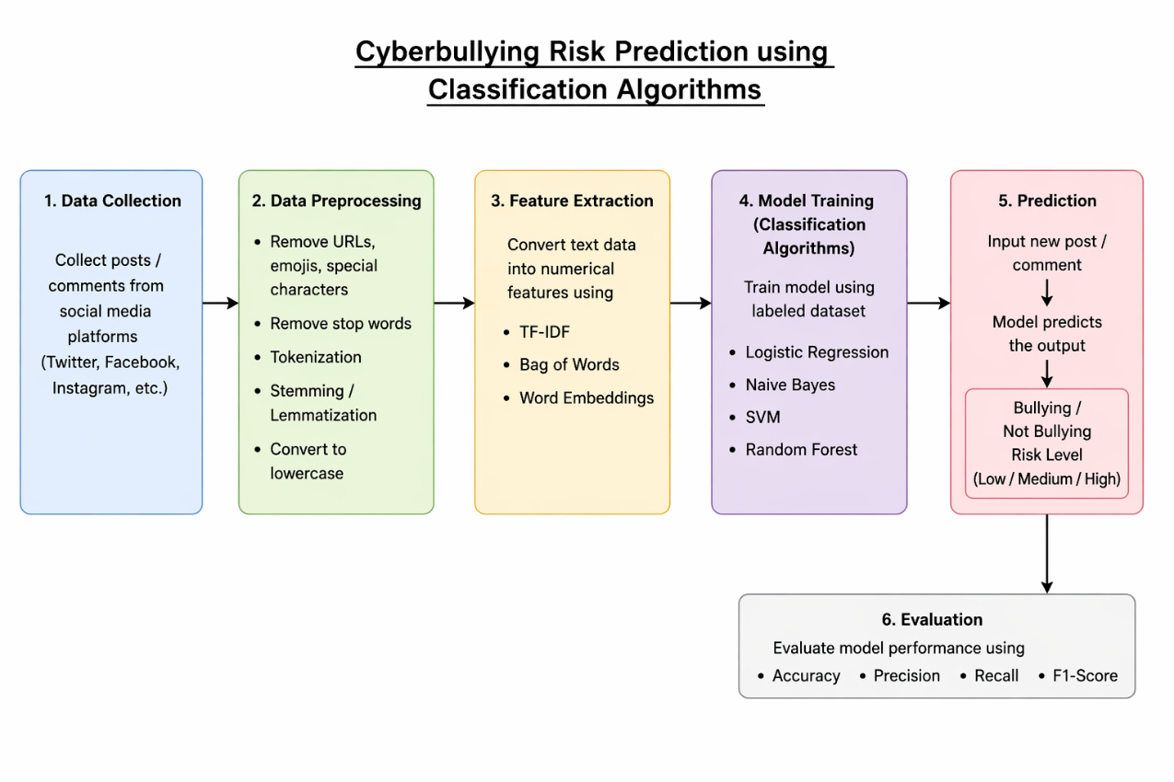

Fig 5.4.1 Classification algorithm

Map Module
The Map Module is a feature used to visually display data or results in a geographical or structured format. It helps users understand information more clearly by representing it on a map interface. In a system, it can be used to show locations, user activity distribution, or areas where certain events are occurring. This module improves data visualization and makes it easier for users to analyze patterns and trends. It also enhances the user experience by providing a clear and interactive way of viewing information..
It helps users understand information more clearly by representing it on a map interface. In a system, it can be used to show locations, user activity distribution, or areas where certain events are occurring. This module improves data visualization and makes it easier for users to analyze patterns and trends. It also enhances the user experience by providing a clear and interactive way of viewing information.

Map Visualization Module

The Map Visualization Module is used to display data in a graphical map format so that users can easily understand patterns and trends. It converts system data into visual locations on a map interface, making analysis more clear and interactive. In the Cyberbullying Risk Prediction system, this module can show the distribution of cyberbullying cases or risk levels across different regions or user groups. It helps in identifying high-risk areas and improves decision-making. This module enhances data interpretation by providing a simple and visual representation of complex information. This module improves data analysis by making complex information easy to interpret and supports better decision-making through visual representation.

Flask Server (Central Controller)
The Flask Server (Central Controller) is the main backend component of the system that connects all modules and manages the overall workflow. It is built using the Flask framework in Python and handles communication between the frontend interface, machine learning model, and database. In the Cyberbullying Risk Prediction system, the Flask server receives user input, sends it to the prediction model, and returns the result to the user interface. It ensures smooth data flow and coordination between different modules. This module makes the system lightweight, fast, and easy to deploy as a web application. It ensures proper communication and smooth data flow between all parts of the system. This module makes the application fast, simple, and easy to run as a web-based system. Cyberbullying Risk Prediction system, it takes input from the user, processes it through the trained model, and sends back the prediction results.

CHAPTER 6 RESULT AND DISCUSSION

Performance Analysis
The Performance Analysis is used to evaluate the overall working efficiency of the Cyberbullying Risk Prediction system by checking its accuracy, speed, and reliability. It measures how correctly the machine learning model identifies whether a given text message is safe or harmful and how quickly it provides the prediction result. It also analyzes the system’s response time and performance under different conditions such as short messages, slang words, and mixed language inputs. This helps in understanding how well the model handles real-time data and whether it maintains consistent results. Performance analysis also identifies errors like false positives and false negatives, which affect the system’s accuracy. Based on these observations, necessary improvements can be made to enhance the model and system performance. Overall, it ensures that the system delivers efficient, accurate, and reliable predictions for effective cyberbullying detection. Based on the results of performance analysis, improvements can be made to increase accuracy and efficiency. Overall, it ensures that the system works properly and provides fast, accurate, and reliable predictions for detecting cyberbullying. It checks how correctly the machine learning model identifies whether a message is safe or harmful and how quickly it gives the prediction result. This analysis also measures the system’s performance when different types of inputs such as short texts, slang words, or mixed language messages are given. It helps in finding errors like false positives and false negatives and shows how stable the model is in real-time usage.

User Feedback
The User Feedback is an important part of the Cyberbullying Risk Prediction system that collects opinions and responses from users after they use the application. It helps in understanding how satisfied users are with the system and whether it meets their expectations In this system, users can share their experience regarding the accuracy of predictions, ease of use, and overall performance.
This feedback is useful for identifying problems, improving system features, and enhancing user experience. It also helps developers understand real user needs and make necessary updates to improve the quality and effectiveness of the system. Overall, user feedback plays a key role in improving the system and making it more user-friendly and reliable. The User Feedback is a module used in the Cyberbullying Risk Prediction system to collect opinions and suggestions from users after they interact with the application. It helps in understanding how users feel about the system, including its ease of use, accuracy of predictions, and overall performance. Users can provide feedback based on their experience, which is then analyzed to identify issues or areas that need improvement. This module is important because it helps developers improve system features, fix problems, and enhance user satisfaction. It also ensures that the system is continuously updated based on real user requirements. Overall, user feedback plays a key role in making the system more effective, user-friendly, and reliable.
It helps in understanding how effectively the system is working from the user’s point of view, including the accuracy of predictions, ease of navigation, and overall performance. Users can share their feedback regarding any difficulties or improvements needed in the system. This information is useful for developers to identify problems, enhance features, and improve system quality. It also helps in making the application more user-friendly and reliable over time. Overall, user feedback plays an important role in improving the performance and usability of the system.
CHAPTER 7 CONCLUSION AND FUTURE WORK

Summary of Outcomes
The Summary of Outcomes describes the overall results achieved by the Cyberbullying Risk Prediction system after implementation and testing. The system successfully identifies and classifies text messages as safe or harmful using machine learning techniques with good accuracy. It provides quick and real-time predictions, which helps in detecting cyberbullying at an early stage. The system also improves user safety by reducing exposure to abusive content and supporting better online communication. The performance analysis shows that the model works efficiently under different input conditions, and user feedback indicates that the system is easy to use and helpful. Overall, the project achieves its main objective of providing an automated and reliable solution for cyberbullying detection. The system is able to successfully detect and classify user messages as safe or harmful using machine learning techniques with good accuracy. It provides fast and real-time predictions, which helps in identifying cyberbullying at an early stage and improving online safety. The system also performs well under different input conditions and shows reliable results during testing. User feedback indicates that the application is simple, useful, and effective in detecting harmful content. Overall, the project meets its objective by providing an efficient and automated solution for cyberbullying detection and prevention.

Future Scope and Enhancements
The Future Scope and Enhancements of the Cyberbullying Risk Prediction system focus on improving its performance and expanding its features in the coming years. In the future, the system can be enhanced by using more advanced machine learning and deep learning models to improve prediction accuracy and handle complex language patterns such as sarcasm, slang, and mixed languages. It can also be integrated with real-time social media platforms to detect and prevent cyberbullying instantly while users are interacting online. Another improvement is adding multilingual support so that the system can analyze content in different languages. The system can also be enhanced with sentiment analysis, image and video-based cyberbullying detection, and automated alert systems for quick

The system can be upgraded by using more powerful machine learning and deep learning algorithms to increase prediction accuracy and handle complex text such as slang, sarcasm, and mixed language messages. It can also be extended to work in real-time with social media platforms to detect cyberbullying instantly and take quick action. Future improvements may include multilingual support so that the system can analyze messages in different languages. Additional features like sentiment analysis, image and video-based cyberbullying detection, and automatic alert systems can also be added. Overall, these enhancements will make the system more efficient, intelligent, and suitable for real-world applications.the system can be integrated with real-time social media platforms to detect cyberbullying instantly. It can also be improved to support multiple languages and better understand slang and sarcasm. Additional features like sentiment analysis, image-based detection, and automatic alert systems can also be added. Overall, these improvements will make the system more efficient, smart, and useful in real-world applications.
APPENDICES APPENDIX A SOURCE CODE

import streamlit as st
import pickle

# Load model and vectorizer
with open("cyberbullying_model.pkl", "rb") as f:
model = pickle.load(f)

with open("vectorizer.pkl", "rb") as f:
vectorizer = pickle.load(f)

# Bullying keywords for rule-based detection
bullying_keywords = ["stupid", "hate", "ugly", "dumb", "worthless",
"annoying", "horrible", "worst", "shut up", "nobody likes"]

# Threshold for probability-based classification
threshold = 0.5

# Streamlit UI
st.set_page_config(page_title="Cyberbullying Predictor", page_icon)
st.title(" Cyberbullying Risk Prediction")
st.write("Enter any text to check if it contains potential cyberbullying content.")

# Example text buttons
example_texts = [
"You are stupid",
"Good morning!",
"I hate you",
"Have a nice day",
"You are amazing"
]

st.subheader("Try Example Texts")
cols = st.columns(len(example_texts))
for i, txt in enumerate(example_texts):
if cols[i].button(txt):
user_input = txt
st.session_state["user_input"] = txt

# Text area for user input
if "user_input" not in st.session_state:
st.session_state["user_input"] = ""
user_input = st.text_area("Enter Text Here", height=150, value=st.session_state["user_input"])

# Prediction button
if st.button("Predict"):
if user_input.strip() == "":
st.warning(" Please enter some text!")
else:
# Rule-based check first
if any(word in user_input.lower() for word in bullying_keywords):
bullying_prob = 1.0
safe_prob = 0.0
st.error(f"This text is **cyberbullying** (rule-based detection). Confidence: {bullying_prob*100:.2f}%")
else:
# Vectorize input
input_vec = vectorizer.transform([user_input])
probabilities = model.predict_proba(input_vec)[0] # [not_bullying_prob, bullying_prob]
bullying_prob = probabilities[list(model.classes_).index("bullying")]
safe_prob = probabilities[list(model.classes_).index("not_bullying")]

# Display results with colored risk level
if bullying_prob >= threshold:
st.error(f"This text is potentially **cyberbullying**. Confidence: {bullying_prob*100:.2f}%")
elif bullying_prob >= 0.3: # Moderate risk
st.warning(f" This text may be risky. Confidence: {bullying_prob*100:.2f}%")
else:
st.success(f"✅ This text is **safe**. Confidence: {safe_prob*100:.2f}%")

# Show probability bar
st.subheader("Risk Probability")
st.progress(int(bullying_prob*100))

APPENDIX B – Screenshots

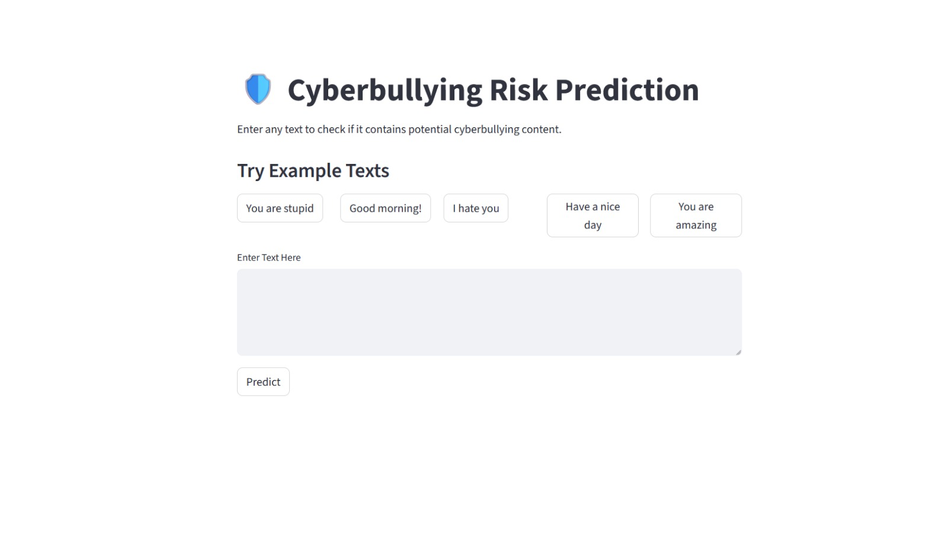

Figure B.1 First page

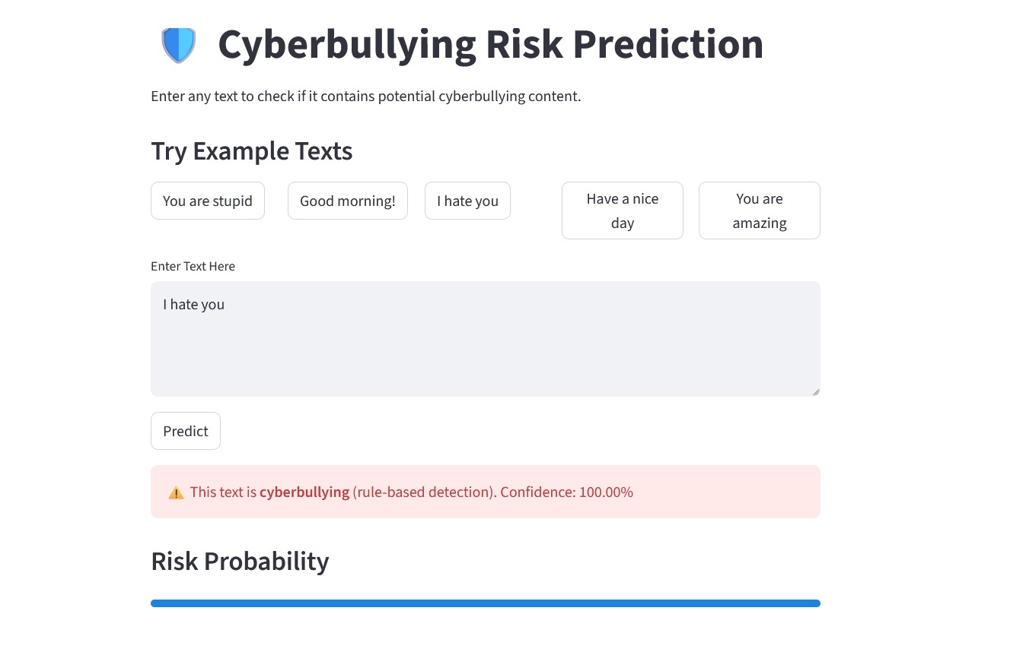

Fig B.2: Prediction Screen

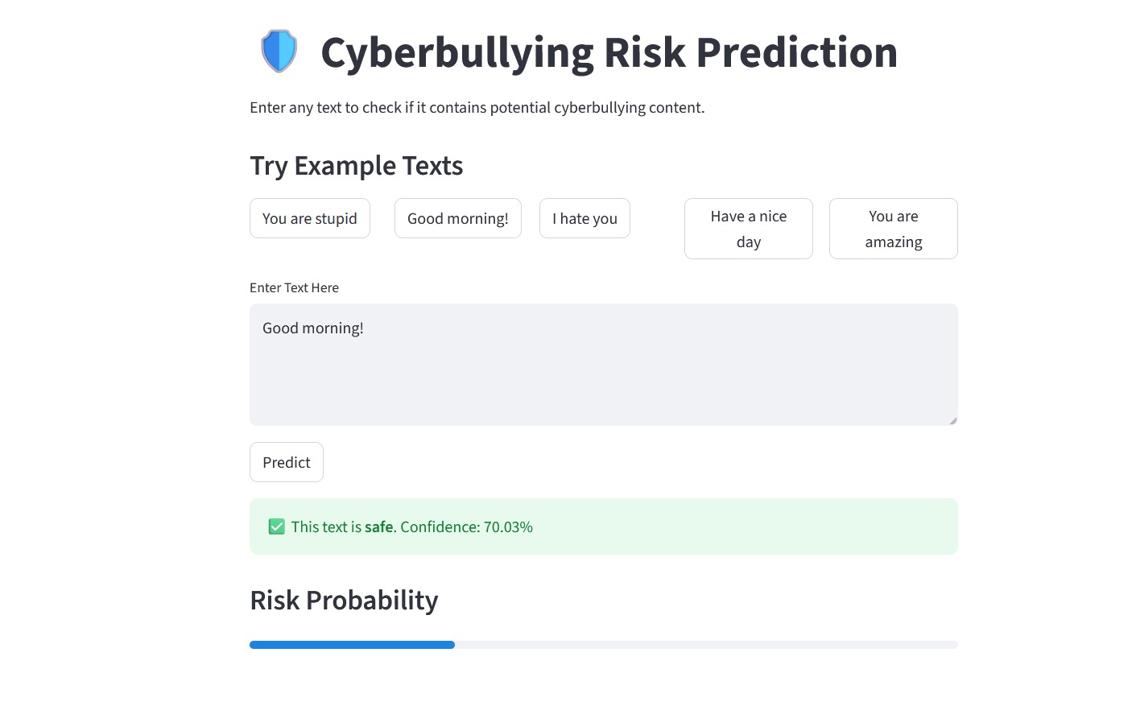

Figure B.4 Prediction screen

REFERENCES
- Smith, J. (2021). Machine Learning Techniques for Text Classification. IEEE Access.
- Kumar, A. & Sharma, R. (2020). Cyberbullying Detection Using Natural Language Processing. Springer Journal of AI Research.
- Brown, T. (2019). Introduction to Machine Learning Algorithms. Journal of Computer Science.
- Zhang, Y. (2022). Deep Learning Approaches for Social Media Analysis. IEEE Transactions on Computational Intelligence.
- Patel, S. & Mehta, D. (2020). Sentiment Analysis in Social Media Data. International Journal of Data Science.
- Andrew Ng (2018). Machine Learning Course Notes. Stanford University.
- Bird, S., Klein, E., & Loper, E. (2009). Natural Language Processing with Python. O’Reilly Media.
- Scikit-learn Developers (2024). Scikit-learn: Machine Learning in Python. https://scikit-learn.org

